Website Analysis Report

**Overview:**

*This report analyses the website for Sidcup Family Golf, a Toptracer driving range and crazy golf venue located in Sidcup, South East London.*

**Target Audience:**



The target audience for Sidcup Family Golf website includes:

**Golf Enthusiasts**: Individuals passionate about golf, looking for a modern and tech-driven golfing experience.

**Families:** Emphasising the family-friendly nature of the venue, appealing to parents and children seeking recreational activities.

**Technology Enthusiasts**: Showcasing Toptracer Range technology to attract individuals interested in the latest advancements in golf technology.

**Key Features and Learnings:**

**1. Toptracer Range Technology:**

The website effectively highlights the Toptracer Range technology, offering an engaging, tech-driven experience for seasoned players and newcomers alike. The incorporation of videos and descriptive content enhances the understanding of this unique feature.

**2. Adventure Golf:**

The Adventure Golf section is well-presented, emphasising the fun and adventurous aspects of the venue. The use of dinosaur-themed crazy golf courses adds a unique and appealing touch.

**3.** **Golf Lessons:**

The website communicates a commitment to player development through both group and individual lessons. This section is well-structured and caters to golfers of all skill levels.

**4. User Testimonials:**

The inclusion of user testimonials on Page 3 adds credibility and positive social proof. Real-life experiences contribute to building trust among potential visitors.



**5.** **Call to Action (CTA):**

The "What Are You Waiting For?" section on Page 4 effectively prompts visitors to take action. The clear CTAs for Toptracer Range, Adventure Golf, and Golf Lessons provide a straightforward path for users to explore further.

**Design and Multimedia Elements:**

**Visual Appeal:** The use of images, videos, and icons enhances the visual appeal, creating an immersive experience for visitors.

**Consistent Branding**: The consistent use of the logo, colour scheme, and visual elements across pages strengthens the branding identity.

**Contact Information:**

The footer includes essential contact information, providing users with easy access to key details such as location and contact numbers.

**Conclusion:**

The Sidcup Family Golf website effectively communicates its offerings to a diverse audience. Implementing the above recommendations can further enhance the user experience and contribute to the success of the venue.

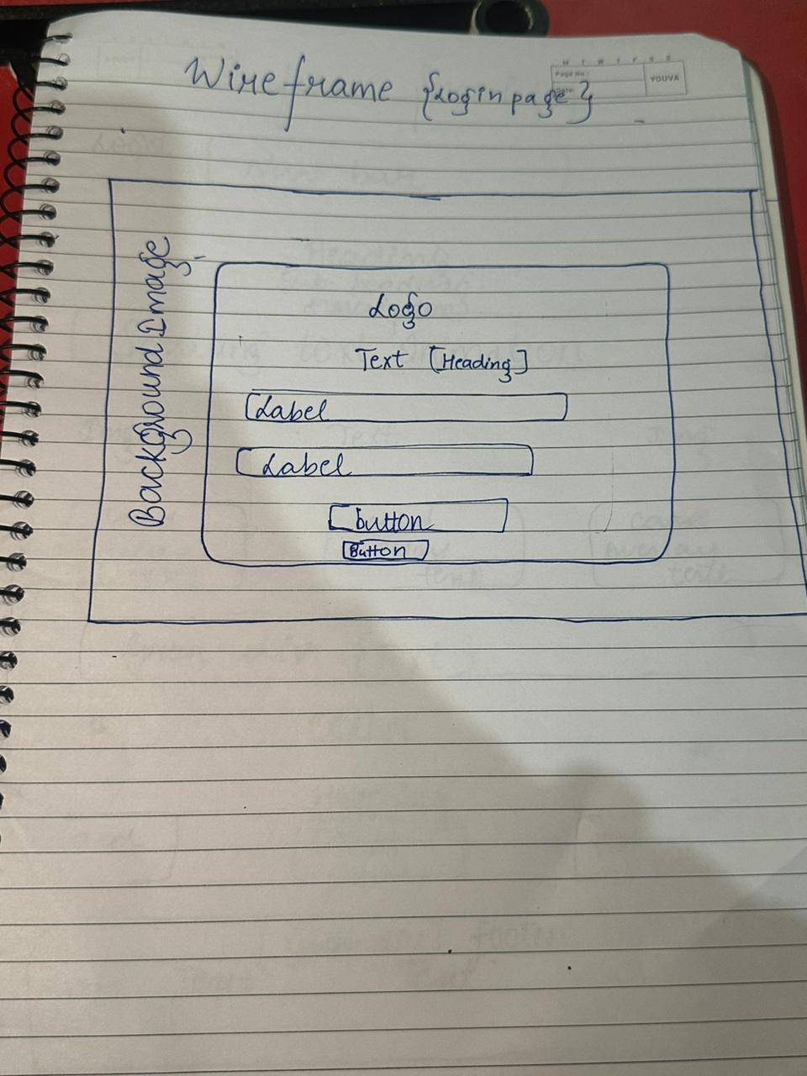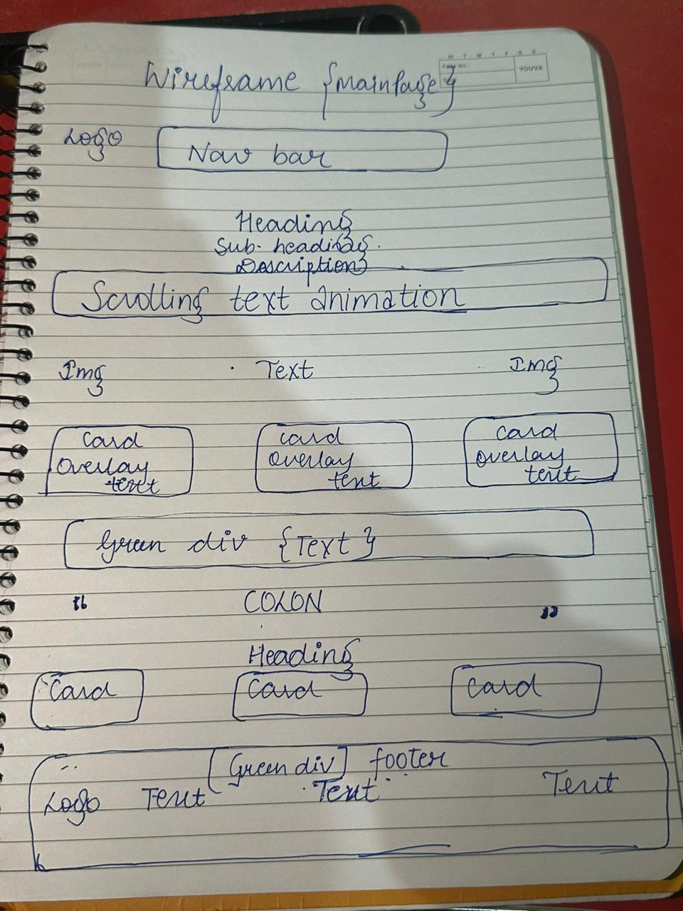

**My Key learnings while making this website :-**

* Scrolling Animation
* Cursor Highlight
* Visual enhancement
* Colon Animation
* Stylesheet advanced functions
* Javascript details

**Link to preview live website :-** [Please click here](https://keshwam-7.github.io/golf.github.io/)

**P.s :** Due to GitHub's limitation on file sizes exceeding 25MB, the background video on the live website is currently inactive. To experience the site with the video, kindly consult the provided code and execute it accordingly.